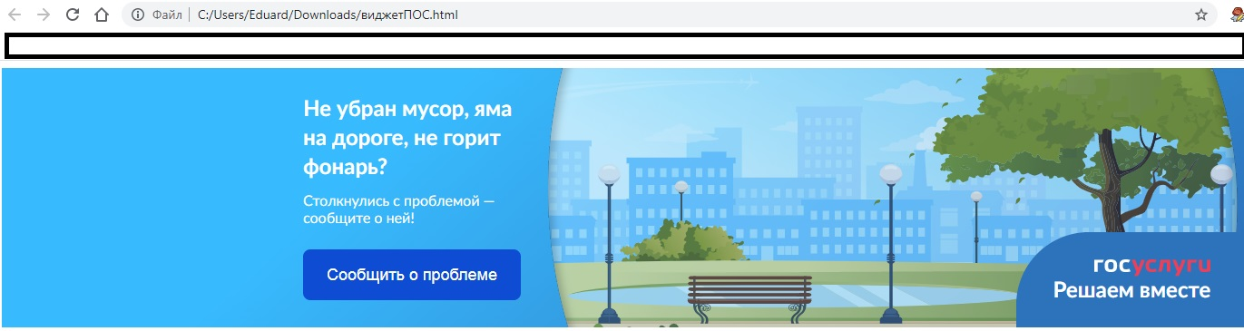

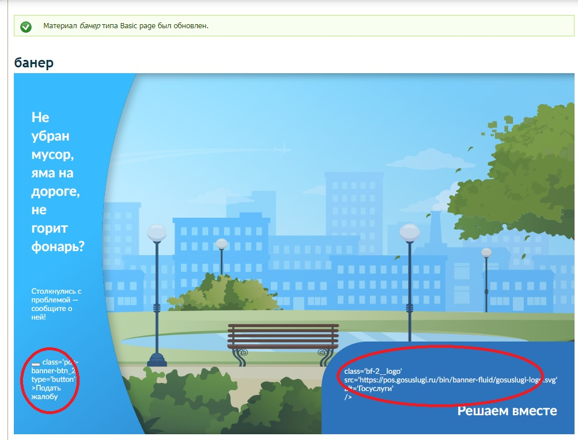
<script src='https://pos.gosuslugi.ru/bin/script.min.js'></script>
<style>
@charset "UTF-8";#js-show-iframe-wrapper{position:relative;display:flex;align-items:center;justify-content:center;width:100%;min-width:293px;max-width:100%;background:linear-gradient(138.4deg,#38bafe 26.49%,#2d73bc 79.45%);color:#fff; cursor: pointer;}#js-show-iframe-wrapper .pos-banner-fluid *{box-sizing:border-box}#js-show-iframe-wrapper .pos-banner-fluid .pos-banner-btn_2{display:block;width:195px;min-height:56px;font-size:18px;line-height:24px;cursor:pointer;background:#0d4cd3;color:#fff;border:none;border-radius:8px;outline:0}#js-show-iframe-wrapper .pos-banner-fluid .pos-banner-btn_2:hover{background:#1d5deb}#js-show-iframe-wrapper .pos-banner-fluid .pos-banner-btn_2:focus{background:#2a63ad}#js-show-iframe-wrapper .pos-banner-fluid .pos-banner-btn_2:active{background:#2a63ad}@-webkit-keyframes fadeInFromNone{0%{display:none;opacity:0}1%{display:block;opacity:0}100%{display:block;opacity:1}}@keyframes fadeInFromNone{0%{display:none;opacity:0}1%{display:block;opacity:0}100%{display:block;opacity:1}}@font-face{font-family:LatoWebLight;src:url(https://pos.gosuslugi.ru/bin/fonts/Lato/fonts/Lato-Light.woff2) format("woff2"),url(https://pos.gosuslugi.ru/bin/fonts/Lato/fonts/Lato-Light.woff) format("woff"),url(https://pos.gosuslugi.ru/bin/fonts/Lato/fonts/Lato-Light.ttf) format("truetype");font-style:normal;font-weight:400;text-rendering:optimizeLegibility}@font-face{font-family:LatoWeb;src:url(https://pos.gosuslugi.ru/bin/fonts/Lato/fonts/Lato-Regular.woff2) format("woff2"),url(https://pos.gosuslugi.ru/bin/fonts/Lato/fonts/Lato-Regular.woff) format("woff"),url(https://pos.gosuslugi.ru/bin/fonts/Lato/fonts/Lato-Regular.ttf) format("truetype");font-style:normal;font-weight:400;text-rendering:optimizeLegibility}@font-face{font-family:LatoWebBold;src:url(https://pos.gosuslugi.ru/bin/fonts/Lato/fonts/Lato-Bold.woff2) format("woff2"),url(https://pos.gosuslugi.ru/bin/fonts/Lato/fonts/Lato-Bold.woff) format("woff"),url(https://pos.gosuslugi.ru/bin/fonts/Lato/fonts/Lato-Bold.ttf) format("truetype");font-style:normal;font-weight:400;text-rendering:optimizeLegibility}
</style>

<style>
#js-show-iframe-wrapper .bf-2{position:relative;display:grid;grid-template-columns:var(--pos-banner-fluid-2__grid-template-columns);grid-template-rows:var(--pos-banner-fluid-2__grid-template-rows);width:100%;max-width:1060px;font-family:LatoWeb,sans-serif;box-sizing:border-box}#js-show-iframe-wrapper .bf-2__decor{grid-column:var(--pos-banner-fluid-2__decor-grid-column);grid-row:var(--pos-banner-fluid-2__decor-grid-row);padding:var(--pos-banner-fluid-2__decor-padding);background:var(--pos-banner-fluid-2__bg-url) var(--pos-banner-fluid-2__bg-position) no-repeat;background-size:var(--pos-banner-fluid-2__bg-size)}#js-show-iframe-wrapper .bf-2__logo-wrap{position:absolute;top:var(--pos-banner-fluid-2__logo-wrap-top);bottom:var(--pos-banner-fluid-2__logo-wrap-bottom);right:0;display:flex;flex-direction:column;align-items:flex-end;padding:var(--pos-banner-fluid-2__logo-wrap-padding);background:#2d73bc;border-radius:var(--pos-banner-fluid-2__logo-wrap-border-radius)}#js-show-iframe-wrapper .bf-2__logo{width:128px}#js-show-iframe-wrapper .bf-2__slogan{font-family:LatoWebBold,sans-serif;font-size:var(--pos-banner-fluid-2__slogan-font-size);line-height:var(--pos-banner-fluid-2__slogan-line-height)}#js-show-iframe-wrapper .bf-2__content{padding:var(--pos-banner-fluid-2__content-padding)}#js-show-iframe-wrapper .bf-2__description{display:flex;flex-direction:column;margin-bottom:24px}#js-show-iframe-wrapper .bf-2__text{margin-bottom:12px;font-size:24px;line-height:32px;font-family:LatoWebBold,sans-serif}#js-show-iframe-wrapper .bf-2__text_small{margin-bottom:0;font-size:16px;line-height:24px;font-family:LatoWeb,sans-serif}#js-show-iframe-wrapper .bf-2__btn-wrap{display:flex;align-items:center;justify-content:center}
</style >
<div id='js-show-iframe-wrapper'>
<div class='pos-banner-fluid bf-2'>

<div class='bf-2__decor'>
<div class='bf-2__logo-wrap'>
<img
class='bf-2__logo'
src='https://pos.gosuslugi.ru/bin/banner-fluid/gosuslugi-logo.svg'
alt='Госуслуги'
/>
<div class='bf-2__slogan'>Жалобы на всё</div >
</div >
</div >
<div class='bf-2__content'>

<div class='bf-2__description'>
<span class='bf-2__text'>
Не убран мусор, яма на дороге, не горит фонарь?
<!-- Не убран мусор, яма на дороге, не горит фонарь?-->
</span >
<span class='pos-banner-fluid__text pos-banner-fluid__text_small'>
Столкнулись с проблемой&nbsp;— сообщите о ней!
<!-- Столкнулись с проблемой&nbsp;— сообщите о ней!-->
</span >
</div >

<div class='bf-2__btn-wrap'>
<!-- pos-banner-btn_2 не удалять; другие классы не добавлять -->
<button
class='pos-banner-btn_2'
type='button'
>Подать жалобу
</button >
</div >

</div >

</div >
</div >
<script>
"use strict";var root=document.documentElement,banner=document.getElementById("js-show-iframe-wrapper");function displayWindowSize(){var o=banner.offsetWidth;o<=405&&(root.style.setProperty("--pos-banner-fluid-2__grid-template-columns","100%"),root.style.setProperty("--pos-banner-fluid-2__grid-template-rows","310px auto"),root.style.setProperty("--pos-banner-fluid-2__decor-grid-column","initial"),root.style.setProperty("--pos-banner-fluid-2__decor-grid-row","initial"),root.style.setProperty("--pos-banner-fluid-2__decor-padding","30px 30px 0 30px"),root.style.setProperty("--pos-banner-fluid-2__content-padding","0 30px 30px 30px"),root.style.setProperty("--pos-banner-fluid-2__bg-url","url('https://pos.gosuslugi.ru/bin/banner-fluid/2/banner-fluid-bg-2-small.svg')"),root.style.setProperty("--pos-banner-fluid-2__bg-position","calc(10% + 64px) calc(100% - 20px)"),root.style.setProperty("--pos-banner-fluid-2__bg-size","cover"),root.style.setProperty("--pos-banner-fluid-2__slogan-font-size","20px"),root.style.setProperty("--pos-banner-fluid-2__slogan-line-height","32px"),root.style.setProperty("--pos-banner-fluid-2__logo-wrap-padding","20px 30px 30px 40px"),root.style.setProperty("--pos-banner-fluid-2__logo-wrap-top","0"),root.style.setProperty("--pos-banner-fluid-2__logo-wrap-bottom","initial"),root.style.setProperty("--pos-banner-fluid-2__logo-wrap-border-radius","0 0 0 80px")),o>405&&o<=500&&(root.style.setProperty("--pos-banner-fluid-2__grid-template-columns","100%"),root.style.setProperty("--pos-banner-fluid-2__grid-template-rows","310px auto"),root.style.setProperty("--pos-banner-fluid-2__decor-grid-column","initial"),root.style.setProperty("--pos-banner-fluid-2__decor-grid-row","initial"),root.style.setProperty("--pos-banner-fluid-2__decor-padding","30px 30px 0 30px"),root.style.setProperty("--pos-banner-fluid-2__content-padding","0 30px 30px 30px"),root.style.setProperty("--pos-banner-fluid-2__bg-url","url('https://pos.gosuslugi.ru/bin/banner-fluid/2/banner-fluid-bg-2-small.svg')"),root.style.setProperty("--pos-banner-fluid-2__bg-position","calc(10% + 64px) calc(100% - 20px)"),root.style.setProperty("--pos-banner-fluid-2__bg-size","cover"),root.style.setProperty("--pos-banner-fluid-2__slogan-font-size","24px"),root.style.setProperty("--pos-banner-fluid-2__slogan-line-height","32px"),root.style.setProperty("--pos-banner-fluid-2__logo-wrap-padding","30px 50px 30px 70px"),root.style.setProperty("--pos-banner-fluid-2__logo-wrap-top","0"),root.style.setProperty("--pos-banner-fluid-2__logo-wrap-bottom","initial"),root.style.setProperty("--pos-banner-fluid-2__logo-wrap-border-radius","0 0 0 80px")),o>500&&o<=585&&(root.style.setProperty("--pos-banner-fluid-2__grid-template-columns","min-content 1fr"),root.style.setProperty("--pos-banner-fluid-2__grid-template-rows","100%"),root.style.setProperty("--pos-banner-fluid-2__decor-grid-column","2"),root.style.setProperty("--pos-banner-fluid-2__decor-grid-row","1"),root.style.setProperty("--pos-banner-fluid-2__decor-padding","30px 30px 30px 0"),root.style.setProperty("--pos-banner-fluid-2__content-padding","30px"),root.style.setProperty("--pos-banner-fluid-2__bg-url","url('https://pos.gosuslugi.ru/bin/banner-fluid/2/banner-fluid-bg-2-small.svg')"),root.style.setProperty("--pos-banner-fluid-2__bg-position","0% calc(100% - 70px)"),root.style.setProperty("--pos-banner-fluid-2__bg-size","cover"),root.style.setProperty("--pos-banner-fluid-2__slogan-font-size","24px"),root.style.setProperty("--pos-banner-fluid-2__slogan-line-height","32px"),root.style.setProperty("--pos-banner-fluid-2__logo-wrap-padding","30px 30px 24px 40px"),root.style.setProperty("--pos-banner-fluid-2__logo-wrap-top","initial"),root.style.setProperty("--pos-banner-fluid-2__logo-wrap-bottom","0"),root.style.setProperty("--pos-banner-fluid-2__logo-wrap-border-radius","80px 0 0 0")),o>585&&o<=800&&(root.style.setProperty("--pos-banner-fluid-2__grid-template-columns","min-content 1fr"),root.style.setProperty("--pos-banner-fluid-2__grid-template-rows","100%"),root.style.setProperty("--pos-banner-fluid-2__decor-grid-column","2"),root.style.setProperty("--pos-banner-fluid-2__decor-grid-row","1"),root.style.setProperty("--pos-banner-fluid-2__decor-padding","30px 30px 30px 0"),root.style.setProperty("--pos-banner-fluid-2__content-padding","30px"),root.style.setProperty("--pos-banner-fluid-2__bg-url","url('https://pos.gosuslugi.ru/bin/banner-fluid/2/banner-fluid-bg-2-small.svg')"),root.style.setProperty("--pos-banner-fluid-2__bg-position","0% calc(100% - 6px)"),root.style.setProperty("--pos-banner-fluid-2__bg-size","cover"),root.style.setProperty("--pos-banner-fluid-2__slogan-font-size","24px"),root.style.setProperty("--pos-banner-fluid-2__slogan-line-height","32px"),root.style.setProperty("--pos-banner-fluid-2__logo-wrap-padding","30px 30px 24px 40px"),root.style.setProperty("--pos-banner-fluid-2__logo-wrap-top","initial"),root.style.setProperty("--pos-banner-fluid-2__logo-wrap-bottom","0"),root.style.setProperty("--pos-banner-fluid-2__logo-wrap-border-radius","80px 0 0 0")),o>800&&o<=1020&&(root.style.setProperty("--pos-banner-fluid-2__grid-template-columns","min-content 1fr"),root.style.setProperty("--pos-banner-fluid-2__grid-template-rows","100%"),root.style.setProperty("--pos-banner-fluid-2__decor-grid-column","2"),root.style.setProperty("--pos-banner-fluid-2__decor-grid-row","1"),root.style.setProperty("--pos-banner-fluid-2__decor-padding","30px 30px 30px 0"),root.style.setProperty("--pos-banner-fluid-2__content-padding","30px"),root.style.setProperty("--pos-banner-fluid-2__bg-url","url('https://pos.gosuslugi.ru/bin/banner-fluid/2/banner-fluid-bg-2.svg')"),root.style.setProperty("--pos-banner-fluid-2__bg-position","0% center"),root.style.setProperty("--pos-banner-fluid-2__bg-size","cover"),root.style.setProperty("--pos-banner-fluid-2__slogan-font-size","24px"),root.style.setProperty("--pos-banner-fluid-2__slogan-line-height","32px"),root.style.setProperty("--pos-banner-fluid-2__logo-wrap-padding","30px 30px 24px 40px"),root.style.setProperty("--pos-banner-fluid-2__logo-wrap-top","initial"),root.style.setProperty("--pos-banner-fluid-2__logo-wrap-bottom","0"),root.style.setProperty("--pos-banner-fluid-2__logo-wrap-border-radius","80px 0 0 0")),o>1020&&(root.style.setProperty("--pos-banner-fluid-2__grid-template-columns","min-content 1fr"),root.style.setProperty("--pos-banner-fluid-2__grid-template-rows","100%"),root.style.setProperty("--pos-banner-fluid-2__decor-grid-column","2"),root.style.setProperty("--pos-banner-fluid-2__decor-grid-row","1"),root.style.setProperty("--pos-banner-fluid-2__decor-padding","30px 30px 30px 0"),root.style.setProperty("--pos-banner-fluid-2__content-padding","30px"),root.style.setProperty("--pos-banner-fluid-2__bg-url","url('https://pos.gosuslugi.ru/bin/banner-fluid/2/banner-fluid-bg-2.svg')"),root.style.setProperty("--pos-banner-fluid-2__bg-position","0% center"),root.style.setProperty("--pos-banner-fluid-2__bg-size","cover"),root.style.setProperty("--pos-banner-fluid-2__slogan-font-size","24px"),root.style.setProperty("--pos-banner-fluid-2__slogan-line-height","32px"),root.style.setProperty("--pos-banner-fluid-2__logo-wrap-padding","30px 30px 24px 40px"),root.style.setProperty("--pos-banner-fluid-2__logo-wrap-top","initial"),root.style.setProperty("--pos-banner-fluid-2__logo-wrap-bottom","0"),root.style.setProperty("--pos-banner-fluid-2__logo-wrap-border-radius","80px 0 0 0"))}displayWindowSize();var resizeListener=window.addEventListener("resize",displayWindowSize);window.onunload=function(){window.removeEventListener("resize",resizeListener)};
</script>
<script>Widget("https://pos.gosuslugi.ru/form", 265522)</script>

